Captain Stirling Local Hub Steering Committee

MINUTES OF MEETING
5.00pm, Tuesday 13 March 2018
Mayor’s Office, City of Nedlands

Present

Mayor Max Hipkins City of Nedlands
Cr John Wetherall City of Nedlands
Cr Toni James City of Nedlands
Mr Barry Nunn Community Representative

1. Welcome and Apologies

Nil apologies

2. Confirmation of Previous Minutes

Minutes of the meeting of 7 November 2017 were confirmed.
Moved Barry Nunn, seconded Toni James, carried unanimously

3. Steering Committee Submission on LPS3, to include a Town Centre Zone

Background

At its meeting on 24 October 2017 it was resolved that:

Council instructs the Chief Executive Officer to prepare an amendment to Town Planning Scheme No. 2 for incorporation in Local Planning Scheme No. 3 to create a Town Centre Zone for land including that controlled by Woolworths and Aldi, comprising residential, retail and other non-residential uses on the south side of Stirling Highway.

The Committee’s previous meeting of 7 November 2017 agreed on the boundaries of the Town Centre Zone – refer Attachment 1.
Discussion

The Committee unanimously agreed that it should lodge a submission on LPS3 in support of including a Town Centre Zone. The submission needs to refer to the clauses in the Draft Scheme that need to be amended to accommodate the new zone – namely clauses 9, 16, 17 and 32.

Clause 9 Aims of the Scheme should be amended to add the following:

(n) Develop an integrated, vibrant town centre to provide for the needs of Nedlands’ residents.

Clause 16 Table 2 - Zone objectives should be amended to include:

Town Centre • To provide a community focal point for people, services, employment and leisure that are highly accessible and do not adversely impact on adjoining residential areas.
• To provide for daily and weekly household shopping needs, community facilities and a small range of other convenience services.
• To provide a broad range of employment opportunities to encourage diversity within the Centre.
• To ensure a mix of commercial and residential development, which provides for activity and accessibility at the street level and supports the provision of public transport and pedestrian links.
• To provide for range of quality medium and high density residential development, to meet the diverse needs of the community.
• To ensure non-residential active uses are located at street level which are compatible with adjoining residential uses and other non-active uses on upper levels.
• To allow for the development of a mix of varied but compatible land uses such as housing, professional offices, business services, medical centres, showrooms, amusement centres and eating establishments which do not generate nuisances detrimental to the amenity of the district or to the health, welfare and safety of its residents.
• To provide a focal point for the arts.

Note: the above objectives are based on those of the Neighbourhood Centre Zone. The Committee was aware of the views of the Director of Planning (Attachment 2) but believes the Neighbourhood Centre Zoning as proposed in the Draft LPS3 would disperse central activities along the whole of Stirling Highway, which would be undesirable. The balance of what was proposed as Neighbourhood Centre Zone along the Highway should be converted to Mixed Use Zoning.

Clause 17 Table 3 – Zoning Table should be changed to include:

USE AND DEVELOPMENT CLASS Town Centre Zone

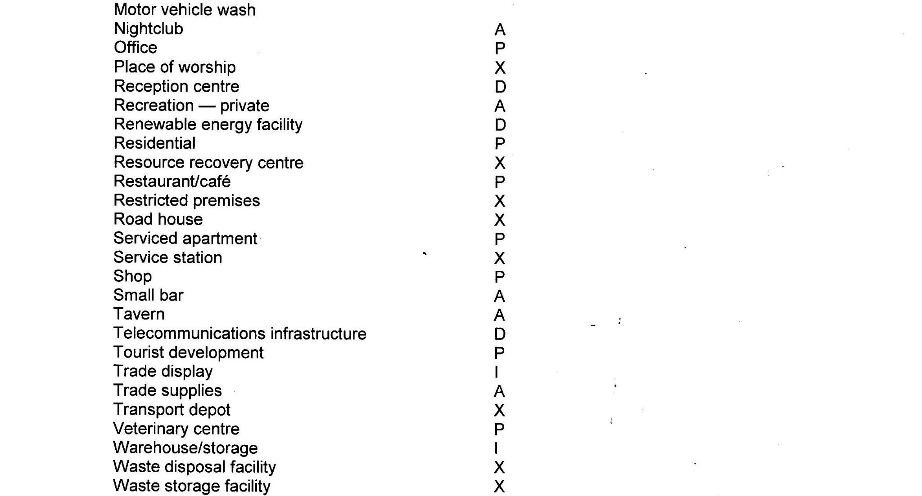
Holiday House X
Motor vehicle repair X
Motor vehicle wash X

* The Committee could not reach agreement on Fast Foods

Clause 32 Table 7 – Additional requirements that apply to land in Scheme area

Description of land Requirement

Town Centre Zone 1. An approved Structure Plan shall guide all
development

2. Land Use
All new development shall comprise a majority of residential floor space.

3. Building setback
There shall be a building setback from Stirling Highway of 2 metres.

4 Vehicle Access
A new access road is to be created between Dalkeith Road and Stanley Street. The owner of any land affected by that road shall cede and construct the portion of that road free of cost as a condition of development approval.

There shall be no direct access from Stirling Highway or from Florence Road south or Stanley Street south.

5. Landscaping
Where the roofs of buildings may be seen from above, they shall be landscaped to the satisfaction of the Council.

6. Public Art
Public art shall be provided in accordance with Council’s Public Art Policy.

4. Any Other Business Nil

5. Date of Next Meeting TBA

Max Hipkins
14 March 2018
Attachment 1 –Town Centre Zone Boundary adopted by Committee 7 Nov 2017
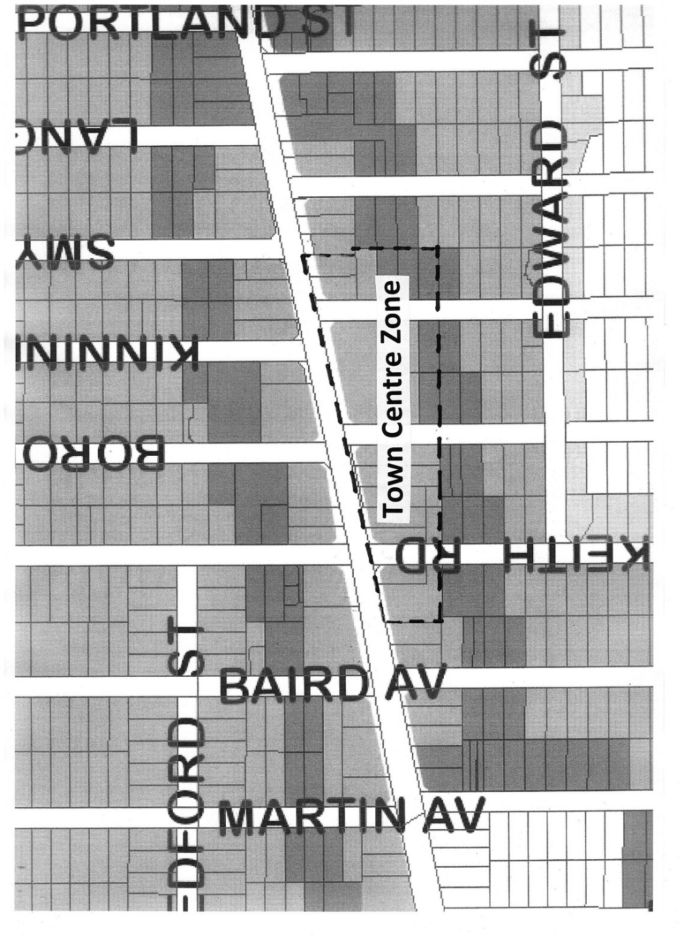

Attachment 2 - Email to Mayor 1 March 2018

In some way the draft LPS3 has “overtaken” the Council resolution of 24 October 2017 in that the site now has a proposed zoning of R-ACO which will allow for “Activity Centre” land uses subject to a structure plan which would be a Local Planning Policy sitting alongside (but outside of) LPS3.
We are proposing a “Precinct Plan” for this and other sites along Stirling Highway and Hampton/Broadway which would detail appropriate land uses, bulk and location controls, bonus provisions and design considerations.

There is also the conflict between this resolution and an earlier Council resolution stating no further changes to TPS2 - something re-inforced by the Deputy Mayor on Tuesday when moving the procedural motion in relation to Scheme Amendment 209 (Philip rd).

So it could be argued that the draft LPS3, as advertised, has dealt with the first part of the resolution in that an appropriate zone has now been created on the “Woolworths and Aldi” sites that provides for (in a Structure or Precinct plan) residential, retail and other non-retail uses.

This is probably all that needs to occur in LPS3 as the detailed rules would be contained in a precinct plan sitting outside of LPS3 as a Local Planning Policy.

Peter Mickleson
Director Planning & Development

